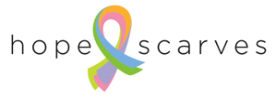

Hope Scarves Partnership Program

Hope Scarves shares scarves, stories and hope with people facing cancer. Each Hope Scarf package contains a scarf, survivor story, scarf tying instructions & information about Hope Scarves.

Most of our constituents connect with Hope Scarves through our website, www.hopescarves.org, either personally or through our gift scarf program where you can send a scarf to someone facing cancer. The Partnership Program brings Hope Scarves directly to patients in places they find support – doctors offices, cancer centers & support organizations. It takes the burden of finding this unique resource off the patient.

The Hope Scarves Partnership Program can be customized to fit the interests and needs of each location.
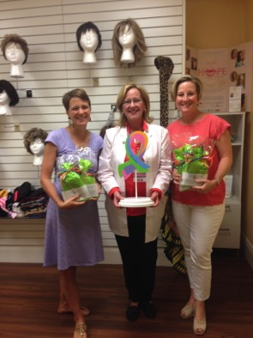
Hope Scarves Partnership Program components:
- Each Hope Scarf comes wrapped in a happy, creative package. Programs range in size from 10-500+ scarves.
- When a scarf package is given to a patient she fills out a short form. The partner location scans the form and emails to Hope Scarves.
- The form allows Hope Scarves to follow up with the recipient three times during the following year, connecting her to our network of support. This also helps tell the story of the program at each location- age, cancer diagnosis, etc… and support funding efforts. (Personal information is not shared.)
- Materials can be customized with each location logo & wording.
- Training and promotional material provided to ensure success.
Launching a new program
Sponsorship of the program:
- The Partnership Program is a mission-based funding stream for Hope Scarves, a nonprofit organization.
- The cost of a Hope Scarf is $30.
- Programs are underwritten by corporations, private individuals, hospital foundations, events and more. Hope Scarves offers fundraising and event planning support.
- Donations are 100% tax deductible.
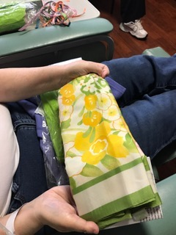
Scarf & Story Collection
A big part of Hope Scarves program is helping survivors live beyond cancer by sharing their story and encouragement with someone else facing cancer. Hope Scarves provides partners with resources to facilitate scarf & story drives as a survivorship resource and meaningful way to support Hope Scarves.

For more information contact Hope Scarves, 502.333.9715 or annalaura@hopescarves.org
Hope Scarves is a 501(c)3 non-profit organization founded in 2012 and based in Louisville, KY. www.hopescarves.org

