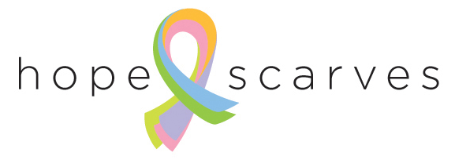

**Hope Scarves Hospital Program**

Hope Scarves partners with survivors to share scarves, stories and hope with women facing cancer. Scarves are sent around the world at no cost to the patient. We also connect with survivors to share their stories and scarves as a way to live beyond cancer.

Most of our constituents connect with Hope Scarves through our website, [www.hopescarves.org](http://www.hopescarves.org). We are interested in working closely with medical institutions to provide the Hope Scarves program directly to patients; ensuring women who might be looking for encouragement from a survivor and a scarf to wear during treatment are connected with Hope Scarves. We have been working with Norton Cancer Institute since 2013 on a pilot hospital program and are excited to roll the program out to other hospitals.

The Hope Scarves Hospital Program can be customized to fit the interests and needs of each hospital. Meaning you can pick and choose which components fit your institution and patient’s needs.



Hope Scarves Hospital Program components include:

* Hope Scarves packages for patients. ($30/scarf)
  + Each brightly wrapped Hope Scarf package includes a headcover, story of hope from a survivor, scarf tying instructions and custom information about the program at your hospital.
  + When a scarf package is given to a patient she fills out a short form which is scanned and emailed to Hope Scarves by the hospital.
  + Hope Scarves will follow up with the recipient three, six months and 1 year following the date she received her scarf, encouraging her as she faces cancer and with information on how to add her story and send the scarf back to Hope Scarves to continue on to another patient if she is interested in doing so.
  + Promotional material such as brochures and brochure holders that the hospital can put out in resource libraries, waiting areas, etc.… to tell patients about program.
  + Hope Scarves will speak to nurses, social workers or others who work with patients so they are aware of the program.
* Scarf Collection Boxes ($100 each)
  + A big part of Hope Scarves program is helping survivors live beyond breast cancer by sharing their story and encouragement with someone else facing cancer. Hope Scarves will provide the hospital with drop boxes and story forms for survivors to share their scarves and stories of hope with others.

The hospital program can be customized to fit the unique needs of each institution. Our smallest program is 10 scarves ($300 donation) and our largest is 250 ($7500). Programs are funded in a variety of ways- events, hospital foundation support, private partner, etc… Hope Scarves can assist in fundraising ideas and implementation. Do not let fundraising to be a barrier to bringing this program to your hospital!

For more information contact Hope Scarves, 502.333.9715 or email [Lara@hopescarves.org](mailto:Lara@hopescarves.org)

*Hope Scarves is a 501(c)3 non-profit organization founded in 2012 and based in Louisville, KY. www.hopescarves.org*