2018 - $300,000
In 2018, Hope Scarves raised $150,000 for metastatic breast cancer research, matched 1:1 by anonymous donors for a total investment of $300,000. With advisement from oncologists, researchers, and patients, we divide our research between translational science and clinical trials. As such, we funded five projects at:
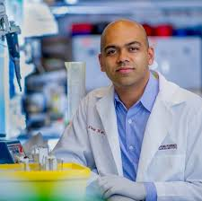
Dana-Farber Cancer Center at Harvard University: One of the main projects of the Wagle Lab is the utilization of molecular and genomic studies to improve our understanding of resistant ER+ metastatic breast cancer. The group hypothesizes that intrinsic and acquired resistance to therapies that target the estrogen receptor will involve genomic and/or molecular alterations that result in different cell states that indicate sensitivity or resistance to therapies. To test this, and with support from Hope Scarves, the Wagle Lab is developing a Resistance Atlas in ER+ MBC. Once completed, this project should bring new insights about pathways and dependencies in resistant ER+ metastatic breast cancers. Long-term, it is hoped that the Resistance Atlas will lead to the development of new therapeutic strategies in breast cancer, including clinical trials and targeted drug combinations, designed to overcome resistance mechanisms and ultimately achieve cure or disease control for the many women and men suffering from ER+ breast cancer.
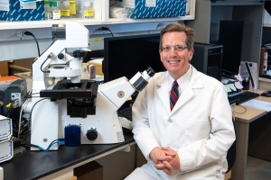
The Johns Hopkins Kimmel Cancer Center: The main focus of the Ewald Lab is on understanding how breast cancer cells build new tumors in distant organs during metastasis. They have shown previously that breast cancer cells spread through the body in groups, attached to each other with molecular Velcro. The protein responsible for these attachments, E-cadherin, is expressed in 90% of breast tumors. With funding from Hope Scarves, the lab showed that E-cadherin was helping breast cancer cells survive during metastasis. Then they developed new experimental methods to model the process of metastatic growth in the lungs. Currently they are using these new approaches to identify systematically new drugs that can prevent metastases. Finally, they showed that breast cancer cells can corrupt cells of the immune system in order to promote metastatic growth and identified therapeutic strategies to restore the ability of the immune system to attack the tumor. Watch Dr. Ewold explain his work.
"Support from Hope Scarves has been critical to our ability move our best ideas rapidly towards patient impact."
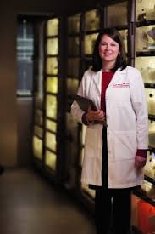
University of Louisville James Graham Brown Cancer Center:
- Expand the biorepository at the JGBCC specific to metastatic breast cancer to allow greater access for scientists which will in turn accelerate our understanding of this disease, with a goal of two additional protocols this year for the biorepository.
- Expand the current metastatic trial portfolio to ensure the options available to breast cancer patients in the region is comprehensive and local to minimize need for travel. The goal of this gift is to open trials in 90 days and offer more depth per subtype.
- Increase patient accruals to these trials which in turn will increase the availability and support of early stage innovative trials. The Goal is to increase trials open in each subtype of metastatic breast cancer along with increase in phase I/II trials with novel targets, immunotherapy.
Collaboration with Metavivor in memory of Laura Williams funded two projects:
- Wei Tao, PhD -The Brigham and Women's Hospital/Harvard University - Multi-staged delivery system overcoming the physiological barriers for metastatic breast cancer (MBC) therapy -(HER2+ MBC focus – small biologic drug conjugates on nanoparticles for targeted treatment of mets)
- Ana Castro-Garrido, MD - Dana-Farber Cancer Institute Identifying predictive biomarkers of response to PD-1 inhibition in metastatic triple-negative breast cancer - (TNBC focus – looking at biomarkers for response to immunotherapy)

2017 - $200,000
In 2017, Hope Scarves raised $100,000 for metastatic breast cancer research, matched 1:1 by anonymous donors for a total investment of $200,000. With advisement from oncologists, researchers, and patients, we divide our research between translational science and clinical trials. As such, projects at:
- Memorial Sloan Kettering Cancer Center– Looking specifically at a new class of MBC drugs called CDK 4/6 inhibitors with the tools of DNA and RNA sequencing to understand and overcome resistance mechanisms.
- Dana-Farber Cancer Center at Harvard University– Researchers there are working to create a “Resistance Atlas” for ER-positive metastatic breast cancer, which should help inform treatment decisions for individual patients and propel the development of new combination treatment strategies. The MBC Project, which Hope Scarves is an Advocate Partner, is a vital part of this ongoing work, providing access to an unprecedented database of genetic information from patients with MBC.

2016 - Hope Scarves' Metastatic Breast Cancer Research Fund was created.
We spent this year understanding the landscape of MBC Research and formalizing our Metastatic Breast Cancer Research Fund.

2015: Our first donation of $50,000 was presented to James Graham Brown Cancer Center at University of Louisville in December 2015.
This gift supported Dr. Yoannis Imbert-Fernandez work to determine the effects of simultaneous suppression of estrogen signaling and a key metabolic enzyme known as PFKFB3 on sugar metabolism, growth and survival of metastatic breast cancer.
