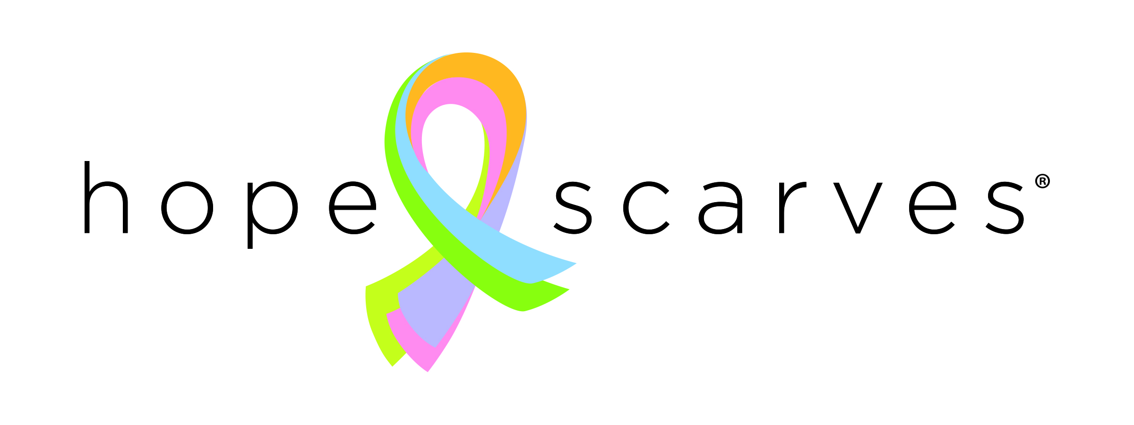

[**www.hopescarves.org**](http://www.hopescarves.org) **| 502-333-9715**

**Community Relations Director**

Hope Scarves is looking for a creative, self-motivated and compassionate team member to help us tell the story of Hope Scarves and change the way people experience cancer. We are hiring a Community Relations Director who will be responsible for the strategy, development and execution of communications, website, and public relations messages and collateral to effectively enhance the Hope Scarves brand.

This position is required for 20 hours per week with a flexible schedule and work at home opportunities, and a willingness to participate in after hours programming events as needed.

**Responsibilities:**

* Manage local and national public relations with support of PR firm
* Develop and manage communications plan and calendar
* Oversee constituent communication to strengthen relationship with supporters including scarf recipients, storytellers, donors and partners. Includes, but not limited to, quarterly newsletters, blog, email campaigns, donor correspondence
* Develop and execute social media strategy to creatively reflect the work of Hope Scarves with lifestyle and curated content
* Manage brand standards & consistent messaging with support of graphic designer
* Manage website design and content
* Collaborate with Hope Scarves staff and board on communication strategy to best tell the Hope Scarves story
* Contribute to donor development and fundraising efforts
* Event planning and execution
* Assist with creative direction and marketing of Hope Scarves merchandise

**Qualifications:**

* Communication (marketing, PR, branding, etc…) experience required
* Fundraising experience preferred but not required
* Prior non-profit experience preferred but not required
* Excellent writing/editing and verbal communication skills
* Experience with various communications and design tools
* Detail and process oriented
* Self-starter, entrepreneurial, and able to work both independently and with a team; enjoys creating and implementing new initiatives
* Passion to support people facing cancer and grow Hope Scarves’ mission

**How to Apply:**

Please email applications to [amy@hopescarves.org](mailto:amy@hopescarves.org) with “Community Relations Director position” in the subject. Please include your current resume and contact information.